**CSC 216 – DIGITAL AND ANALOG COMMUNICATION SYSTEMS**

# **Analog Communication Introduction**

The word communication is derived from the Latin word communicare which means to share. Communication means sharing or exchanging information between two or more individuals (or) systems.

For example, a person communicates with the help of a language, with the help of various facial expressions like smile, angry, nervousness. A traffic police communicates with the help of hand symbols to direct traffic.

## **Communication Definition**

Communication is the process of conveying (sending, receiving and processing) of information between two or more individuals (or) devices

or

Communication is the process of exchange of information between two or more people (or) devices.

## **Communication System Definition**

Communication system is a collection of elements which works together to establish a communication bridge between the sender (transmitter) and receiver.

## **Analog Communication Definition**

Analog communication is the process of conveying (sending, receiving, and processing) of information including image, voice, and video by using continuous signals or analog signals.

For example, a sinusoidal signal is continuous in nature. It has continuous amplitude with continuous time.

## **Analog Communication System Definition**

Analog Communication system is a collection of elements which works together to establish an analog communication bridge between the sender (transmitter) and receiver.

## **Essential parts of communication system**

Any system which provides communication (sends, receives, and process information) consists of three essential parts: sender, receiver and channel as shown in the below figure.

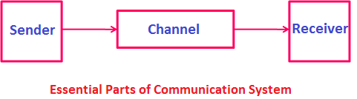

**Sender or Transmitter:**Sender is the person who sends the message. He often called the communicator or source of information. The sender has some kind of information which he wants to share with others (receiver) through a channel. The sender sends the message by speaking, writing or by doing gestures. If we speak technically, all radio transmitting stations or TV transmitting stations are senders, since they transmit information.

**Channel:**Channel is the medium through which message signal travels from sender to receiver. The channel is often referred to as medium. If the sender is speaking, then the channel could be ‘air’. So the sender sends the message signal (sound waves containing message) through the air medium, which will reach the receivers ear drum.

**Receiver:**Receiver is the person who receives the message. Receiver has no information to share but receives the information sent by the sender. The receiver receives the message by listening, reading, or by observing the gestures of a sender. If we speak technically, all TV sets and radios are receivers, since they get information from the transmitting stations.

## **Types of Signals**

A signal is a gesture, action, or sound that is used to convey (send, receive, and process) information between the sender and receiver.

or

A signal is a gesture, action, or sound that is used to establish communication between the sender and receiver.

Signals are classified into various types based on their characteristics. However, they are mainly classified into two types: Analog signals and Digital signals.

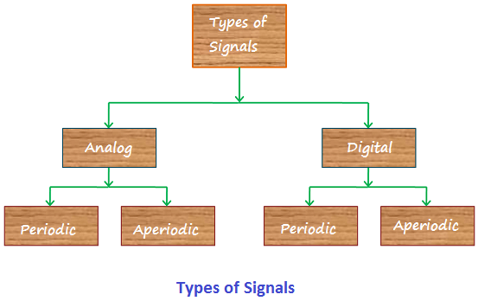

Analog and digital signals are further classified into Periodic and Aperiodic signals, as shown in the below figure.

### **Analog signal**

Analog signal is a continuous signal whose characteristics (amplitude, voltage or frequency) changes continuously over a period of time. For example, in an analog audio signal, the voltage of the signal varies continuously with the pressure of the sound waves. Some examples of analog signals are light signals, electrical signals, human speech signals, and mechanical signals. In an electrical signal, the current, voltage or frequency of the signal may be varied to represent the information.

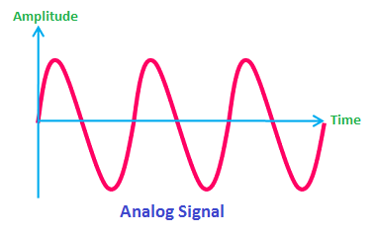

Analog signals are used to send information from one place to another place. Analog signals use some medium to transfer the information from one place to another place. For example, electrical signals use copper cables as the medium to send information from one place to another place; similarly, human speech signals uses air as the medium to send information from one place to another place. Analog signals are generally denoted by sine waves.

In practice, the analog signal experiences noise and distortion in the process of sending information from transmitter to receiver.

### **Digital signal**

Digital signal is a non-continuous electrical signal, which is used to convey (send, receive, and process) information between the sender and receiver. In digital signal, the original information (analog information) is converted into a string of bits (digital information) before being transmitted.

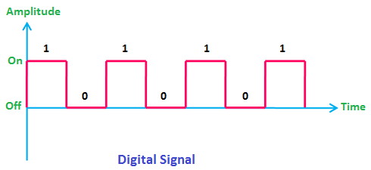

A collection of elements which works together to convey (send, receive, and process) information between the sender and receiver in digital form is called digital communication system. For example, computers are digital in nature. They send, receive, store and process information in binary form, i.e. in the combination of **0**s and **1**s.

### **Periodic signal**

An analog or digital signal which repeats itself after a specific interval of time is called periodic signal. They are deterministic signals.

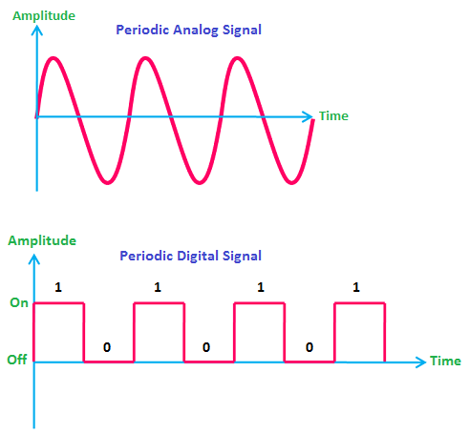

Eg: sine wave, square wave, sawtooth wave, etc.

### **Aperiodic signal**

An analog or digital signal which does not repeats itself after a specific interval of time is called aperiodic signal. They are random signals.

Eg: sound signals from radio, all types of noise signals.

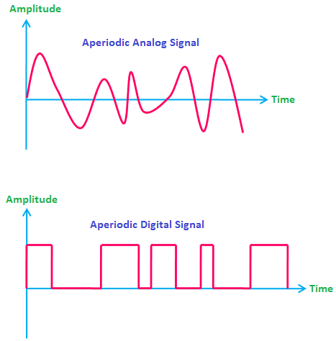

***Difference between Analog Communication and Digital Communication***

In electrical and electronics engineering, the **communication** is defined as the process of broadcasting, transmitting, storing or viewing the data and information using electronic devices and circuits.

Based on the nature of signals and devices used for processing the information, the electronic communication can be classified into following two types −

* Analog Communication
* Digital Communication

In this post, we will take a look at the major differences between analog communication and digital communication by considering various parameters such as basic definition, cost, hardware technology, noise, power requirement, need of modulation, applications, etc. Also, a short description of analog communication and digital communication is added for your reference.

## **What is Analog Communication?**

The type of communication in which the data and information is transferred with the help of analog signals in between transmitter and receiver is called the **analog communication**. Therefore, the analog communication uses **continuous time signals** for transmission of information.

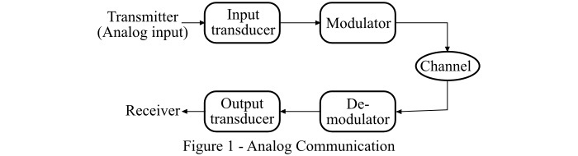

The process involved in analog communication is illustrated in Figure-1. Where, the information in the form of analog signal is input to a transducer, which supplies it to the modulator. The modulator broadcast the modulated information on a communication channel. At receiver end, a demodulator circuit is employed for extracting the information from the modulated signal to produce the output message.

### ***ADVANTAGES of analog communication***

Analog communications obviously came before their digital counterparts, but they did offer specific benefits. For one, signal processing is generally a lot simpler for analog. In many cases, they’re the better choice for the transmission of audio and video. With higher density, they’re able to present information that’s more refined. At the same time, they use less bandwidth compared to digital signals’ high bandwidth. While both kinds of communication rely on the use of an [electrical signal](https://www.sciencedirect.com/topics/engineering/electrical-signal), analog systems have lower sensitivity to electrical tolerance. They also have more precision in representing changes in a variety of physical phenomena, including pressure, position, temperature, sound, and light. They don’t have the same electrical tolerance sensitivity as corresponding digital systems.

***Examples of Analog Communication***

Despite the relative explosion of digital communications and digital electronics, there are some legacy technologies that still use analog signal modulation rather than digital modulation, and many of them require a demodulator for signal reception and communication. Telephones, [tour guide systems](https://www.plant-tours.com/blog/how-tour-guide-systems-work/), image and temperature sensors, audio recordings and reproductions, control systems, and radio signals are all instances where analog communication is still around, even with digital variations present as alternatives. One amplitude modulation drawback is that transmitting a continuous signal over long distances can increase the risk of signal disturbances.

Analog hardware is also more prone to observational errors than digital alternatives. However, there are some areas where digital has yet to compete with analog. For instance, even the best analog-to-digital converters can’t handle signal processing for certain high frequencies. Many digital encoders also rely on analog components and circuits to function. Similarly, a number of digital devices, such as thermometers, use an analog transducer to obtain data before encoding it into digital form.

## **What is Digital Communication?**

The communication in which the information is transferred by using digital signals in between transmitter and receiver is known as **digital communication**.

Hence, in case of digital communication, discrete time signals are used for carrying the information from one point to another. The block diagram shown in Figure-2 illustrates the digital communication system.

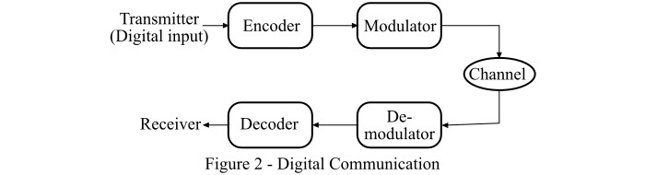

Here, the information is first encoded in digital signals (binary form) and modulated. The modulator then broadcast the information in digital form (in the form of data packets) on the communication channel. On the receiver end, the demodulator recovers the information and supplies it to the decoder, so that output message can be obtained.

### ***ADVANTAGES of digital communication***

Digital transmission has many benefits over analog variants. For starters, participants can communicate with increased range and not have signals or sounds get “fuzzy.” Digital signals have greater noise immunity than analog. When an analog signal encounters waveform distortion, even a small amount affects reception.

Repeater stations allow digital signals to encounter more interference and still reach the receiving end without errors. Synchronization is one of the most common methods that coherent receivers use to process waveform data. It’s efficient, uses low bandwidth, and has better noise immunity. Human voice quality is considerably better, and that can result in lower error rates and better efficiency in company settings. Noise reduction and preservation are both very common qualities of digital communication. It’s also possible to deliver more information. Digital technology is often more flexible, simpler to use, and incredibly portable. Electronic devices that use digital modulation tend to be pricier than their analog counterparts but are becoming increasingly low-cost. Digital communication also allows for utilizing licensed portions of the RF spectrum.

***Examples of Digital Communication***

Digital communication channels range from video conferencing to written communications. Many companies use digital systems internally for their intranet resources, including audio notes, email, project management, video conferences, and instant messaging. As some companies move to a work-at-home business structure, digital communication tools keep employees connected and productive. Some of those applications also fall into the external communications category that you find on the internet, where there are websites, social media, blogs, live chat, display advertising, and audio and video content.

Wireless technology is now in practically everyone’s pockets everywhere, but there can also be specific applications unique to certain environments. Some company locations have [wireless tour guide systems](https://www.plant-tours.com/communication-headsets/wireless-tour-guide-systems/) that allow wireless communication to occur clearly and safely with people in places such as factory floors. It’s also seeing increasing importance in the healthcare field, where it’s used to interact remotely with patients, monitor medical devices from a distance, and transmit vital health information.

## **Difference between Analog Communication and Digital Communication**

The following table highlights the fundamental differences between analog communication and digital communication −

| **Basis of Difference** | **Analog Communication** | **Digital Communication** |
| --- | --- | --- |
| Definition | The method of information transmission between transmitter and receiver in which analog signals are used for conveying the information is known as analog communication. | The communication in which digital signals are used for transferring information between transmitter and receiver is known as digital communication |
| Type of signals used | Analog communication uses continuous time signals. | Digital communication uses discrete time signals. |
| Major components | The main components used for analog communication are: transmitter, transducers, modulator, channel, demodulator and receiver. | The components of digital communication are: transmitter, encoder, modulator, channel, demodulator, decoder and receiver. |
| Signal representation | In analog communication, the sinusoidal waveforms represent the signals used for transferring information. | In digital communication, the signals used for information transmission are represented by square waveforms. |
| Bandwidth | Analog communication needs low bandwidth. | High bandwidth is required in digital communication. |
| Noise | Analog communication is less immune to noise. | The immunity to noise of digital communication is good. |
| Separation of noise | In analog communication, it is not possible to separate the noise signal from message signal. | In digital communication, the noise can be easily separated from the message signal. |
| Error | The probability of error in analog communication is high. | Digital communication has less probability of errors. |
| Hardware design | Analog communication involves complicated and less flexible hardware design. | The hardware design of digital communication is simple and more flexible than analog communication. |
| Modulation techniques | The modulation techniques used in analog communication are: ‘pulse amplitude modulation (PAM)’, ‘pulse width modulation (PWM)’, ‘pulse position modulation (PPM)’. | The modulation techniques used in digital communication are − ‘amplitude shift keying (ASK)’, ‘frequency shift keying (FSK)’, ‘phase shift keying (PSK)’. |
| Multiplexing technique | Analog communication uses frequency division multiplexing (FDM). | Digital communication uses time division multiplexing (TDM). |
| Power consumption | Analog communication involves high power consumption. | Digital communication consumes less power. |
| Security | Analog communication is comparatively less secured. | Digital communication is highly secured. |
| Synchronization | In case analog communication, synchronization of difference components is hard. | The synchronization is easier in case of digital communication. |
| Accuracy | Analog communication is less accurate. | The accuracy of digital communication is high. |
| Number of broadcasting channels | In analog communication, there is a limited number of communication channels that can be broadcasted simultaneously. | In digital communication, a large number of communication channels can be broadcasted simultaneously. |
| Portability of components used | The components used for analog communication are heavy, hence are less portable. | Digital communication involves compact components, hence their portability is high. |
| Cost | Analog communication involves less cost for information transmission. | The cost of digital communication is comparatively high. |

## **Conclusion**

Due to many technical and economic advantages, digital communication has now become the preferred mode of data transmission over analog communication.

**Summary of Differences between Digital Communication and Analog Communication**

|  |  |
| --- | --- |
| Analog Communication | Digital Communication |
| Analog communication uses analog signals for the transmission of information. | Digital communication uses digital signals for the transmission of information. |
| Analog communication uses signals that can be represented by sine waves. | Digital communication uses signals that can be represented by square waves. |
| Analog communication signals consist of continuous values. | Digital communication signals consist of discrete values. |
| Analog communications are affected by noise. | Digital communications are not affected by noise. |
| The probability of error in analog signals is high due to parallax. | Digital signals are virtually immune to parallax errors. |
| Analog communication requires complicated hardware. | Digital communication requires less complicated hardware. |
| Analog communication is relatively cheaper as compared to digital communication. | Digital communication is costly in nature. |
| Low bandwidth is required for analog communication. | High bandwidth is required for digital communication. |
| High power is required for analog communication. | Digital communication requires comparatively less power. |
| Analog communication systems are less portable as they contain heavy and complicated hardware. | Digital communication systems are more portable as compared to analog communication systems. |
| Examples: - Sound shows analog signals | Examples: - Computers use digital signals. |

**Note:**  
Care must be taken that the question asks us the difference between Analog Communication & Digital

# **What are the main sources and types of noise in digital communication systems?**

Noise is any unwanted or interfering signal that affects the quality and reliability of digital communication systems. It can originate from various sources, both internal and external, and can have different effects on the transmitted or received data. In this article, you will learn about the main sources and types of noise in digital communication systems, and how they can be reduced or mitigated.

## ***Internal noise***

Internal noise is the noise that is generated within the components of the communication system, such as amplifiers, transmitters, receivers, or wires. It is mainly caused by the random motion of electrons or other particles in the circuit, which produces thermal noise or Johnson-Nyquist noise. It can also be caused by the imperfect operation of switches, resistors, capacitors, or other devices, which produces shot noise or flicker noise. Internal noise is usually white noise, meaning that it has a constant power spectrum across all frequencies.

***External noise***

External noise is the noise that comes from outside the communication system, such as natural phenomena or human activities. It can be classified into two types: natural noise and man-made noise. Natural noise is the noise that is produced by natural sources, such as lightning, solar flares, cosmic rays, or atmospheric turbulence. It can affect the communication system by inducing electromagnetic interference (EMI) or radio frequency interference (RFI) in the wires or antennas. Man-made noise is the noise that is produced by artificial sources, such as power lines, motors, generators, or other electronic devices. It can also affect the communication system by inducing EMI or RFI, or by creating intentional or unintentional jamming signals.